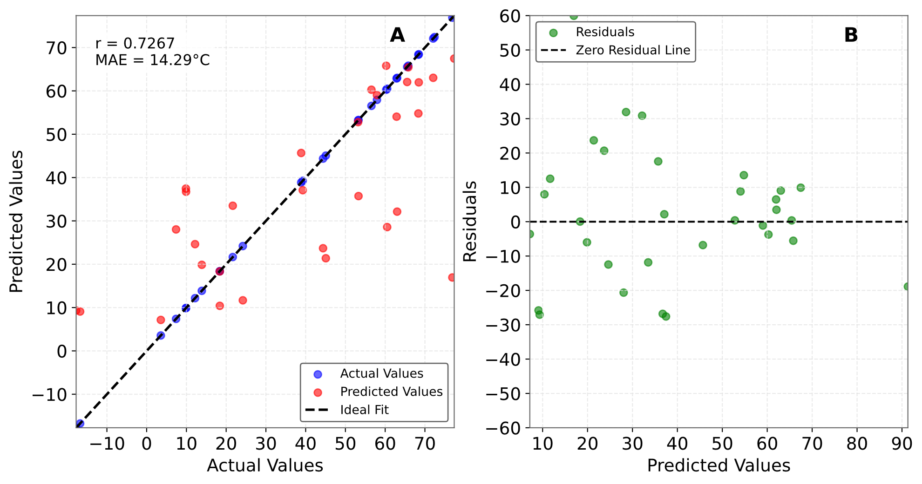
Figure 1 Predicted versus actual Tg °C. The ensemble combines five base models (GBR, Random Forest, SVR, Lasso, ElasticNet) with 10 estimators each (for tree based models), trained on the optimal feature combination [Lignin (wt%), Co-polyol type (PTHF), Ratio, Copolyol (wt%), Isocyanate (wt%)]. Plot A shows the correlation between predicted and actual Tg values for validation and test datasets (n=32), with a Pearson correlation coefficient of r = 0.73 and mean absolute error of 14.29°C. Plot B displays residual analysis showing prediction errors randomly distributed around the zero line, indicating no systematic bias in model predictions.

The ensemble model demonstrates moderate predictive capability for polymer Tg prediction based on compositional parameters. The correlation coefficient of 0.73 and MAE of ~14°C indicate the model captures approximately 53% of the variance in Tg values while maintaining prediction errors within reasonable bounds for materials design applications. The residual analysis confirms model reliability across the temperature range with no systematic prediction biases.

